*****U*NIVERSITY OF *I*NFORMATION *T*ECHNOLOGY & *S*CIENCES (*UITS* )**

**ASSIGNMENT**

**on**

**INTERNET OF THINGS LAB**

⮘**Submitted To**⮚

***Ayanava Paul***

Lecturer,

Department of CSE, UITS

⮘**Submitted By**⮚

***F*AZLAY *R*ABBI**

* Department 🢣 CSE
* ID 🢣 2125051070
* Semester 🢣 Autumn 2024
* Batch 🢣 50
* Section 🢣 7B1
* Subject Code 🢣 CSE 402
* Date of Submission 🢣 09.09.2024

**Signature**

# **One LED blinking**

Title: **Blink one LED using a Arduino UNO R3**

Necessary Equipment: 1. Arduino UNO R3

1. Breakbord
2. 330 Ohom resistor
3. 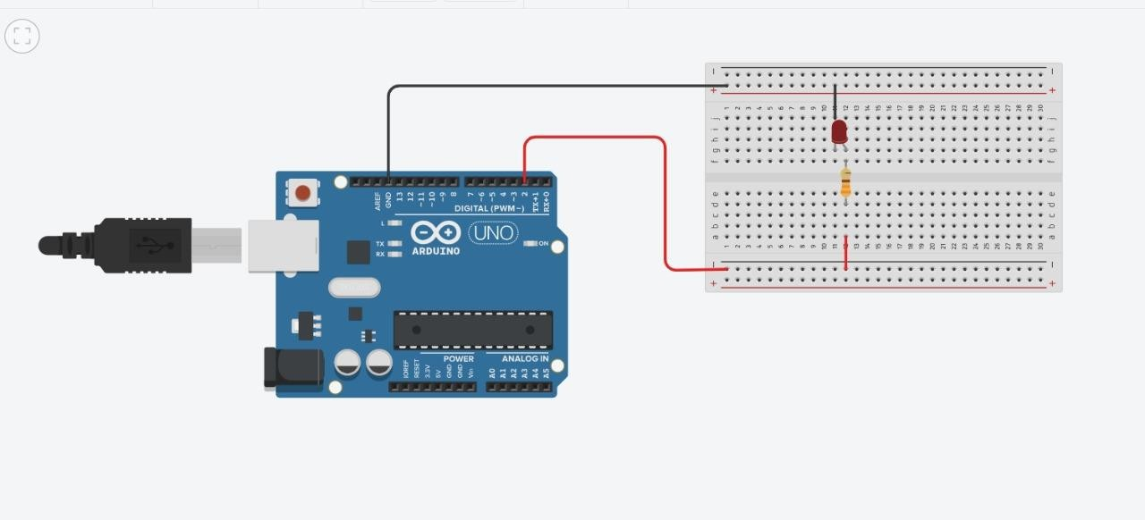One LED

# Multiple LED blinking in reverse order

Title: **Blinking multiple LED in reverse order using a Arduino UNO R3**

Necessary Equipment:

1. Arduino UNO R3
2. Breakbord
3. 330 Ohom resistor
4. 5LED

